Algebra 2

Graphing and Analyzing Exponential Functions Notes





Where 

and

*b* is a positive number **other than** 1

**If b is *__________* 1**



**Is called an exponential _________ function.**

**b is the**

**“______” Factor**

**If b is *_______________***1



**Is called an exponential ____________ function.**

**b is the “______” factor**

**IMPORTANT NOTE: If *x* is negative flip the *b* and make the *x* positive then decide if it is growth or decay.**

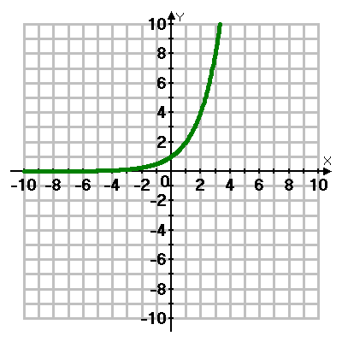Example of Exponential Growth Example of Exponential Decay

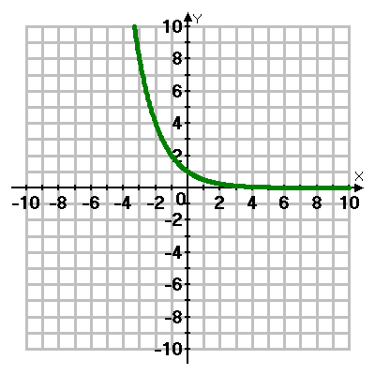

**What to Analyze:**

***Y*-int:** put in zero for *x* (use your table) ordered pair (0, *#*)

**Asymptote:** y = constant

**Domain-** always 

**Range:** If *a* is positive:  If *a* is negative: 

**End Behavior:** To answer EB look at the left and right of the graph and see what the arms are doing. One side will go to either  or while the other side will go to the asymptote.



**Graphing and Analyzing Exponential Functions**

1.  Growth or Decay? 2.  Growth or Decay?

*x y*

0



Yint: ___________ Asymp:___________

D:________________ R:_____________

EB: 

*x y*

0



Yint: ___________ Asymp:___________

D:________________ R:_____________

EB: 

3. Growth or Decay? 4. Growth or Decay?

*x y*

0



Yint: ___________ Asymp:___________

D:________________ R:_____________

EB: 

*x y*

0



Yint: ___________ Asymp:___________

D:________________ R:_____________

EB: 

5. Growth or Decay? 6.  Growth or Decay?

*x y*

0



Yint: ___________ Asymp:___________

D:________________ R:_____________

EB: 

*x y*

0



Yint: ___________ Asymp:___________

D:________________ R:_____________

EB: 

7.  Growth or Decay? 8.  Growth or Decay?

*x y*

0



Yint: ___________ Asymp:___________

D:________________ R:_____________

EB: 

*x y*

0



Yint: ___________ Asymp:___________

D:________________ R:_____________

EB: 

**Notes for graphing base *e***

Use the same rules for graphing exponentials.



 So *e* is just a number!

Graph and analyze

1. 

Yint: ___________ Asymp:___________ D:________________ R:_____________

EB: 



*x y*

0

2. 

Yint: ___________ Asymp:___________ D:________________ R:_____________

EB: 



*x y*

0