The natural base “e”

What is *e*? ______________________________________________________________________________

_________________________________________________________________________________________

Use a calculator to evaluate the expression. Write all decimal places (do not round).

*e* =_______________________________________________________________________________________

Which mathematical concept does this make you think of? _________________________________________

Like pi, the natural base “e” is an __________________________________ number. It can be approximated to _______________. Because of its natural limiting value, it is often used as the base of the exponential function in realistic applications.

We can graph exponential growth functions with base e.

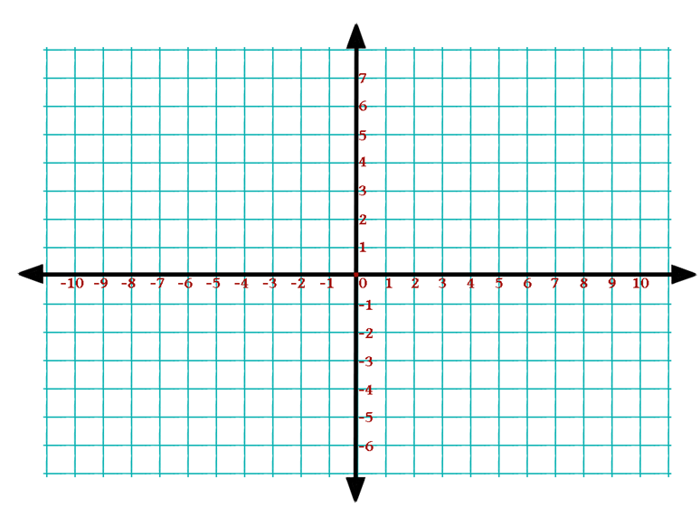EX 1  EX 2 

|  |  |
| --- | --- |
| x | y |
|  |  |
|  |  |
|  |  |
|  |  |
|  |  |
|  |  |

|  |  |
| --- | --- |
| x | y |
|  |  |
|  |  |
|  |  |
|  |  |
|  |  |
|  |  |

Graphing: Natural Base/ Euler’s Number

Graph and analyze the following exponential growth functions. Your graph should accurately show the y –intercept and the asymptote. Determine at least two additional points on the right side of the graph. USE A PENCIL!

|  |  |  |  |  |  |  |  |  |  |  |  |  |  |  |  |  |  |  |  |  |  |  |  |  |  |
| --- | --- | --- | --- | --- | --- | --- | --- | --- | --- | --- | --- | --- | --- | --- | --- | --- | --- | --- | --- | --- | --- | --- | --- | --- | --- |
| [image] 1.   |  |  | | --- | --- | | x | f(x) | | -2 |  | | -1 |  | | 0 |  | | 1 |  | | 2 |  |   y-intercept ________ asymptote _________  domain ________ range _________    end behavior: as x → +, f(x) → __________, and    as x → -, f(x) → __________  [image] | [image]2.     |  |  | | --- | --- | | x | f(x) | | -2 |  | | -1 |  | | 0 |  | | 1 |  | | 2 |  |   y-intercept ________ asymptote _________  domain ________ range __________    end behavior: as x → +, f(x) → __________, and      as x → -, f(x) → __________  [image] |
| 3.   |  |  | | --- | --- | | x | f(x) | | -2 |  | | -1 |  | | 0 |  | | 1 |  | | 2 |  |   y-intercept ________ asymptote _________  domain ________ range _________    end behavior: as x → + $∞$, f(x) → __________, and    as x → - $∞$, f(x) → __________ | 4.   |  |  | | --- | --- | | x | f(x) | | 1 |  | | 2 |  | | 3 |  | | 4 |  | | 5 |  |   y-intercept ________ asymptote _________  domain ________ range _________    end behavior: as x → + $∞$, f(x) → __________, and      as x → - $∞$, f(x) → __________ |