Graphing: Exponential Growth Functions
Graph and analyze the following exponential growth functions. Your graph should accurately show the y –intercept and the asymptote. Determine at least two additional points on the right side of the graph. USE A PENCIL!
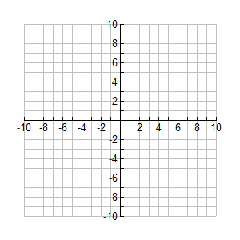  f(x) = (2) ^{x}  x f(x)  -2  -1  0  1  2  y-intercept ________ asymptote _________  domain ________ range _________  end behavior: as x → +$∞$, f(x) → __________, and  as x → -$∞$, f(x) → __________ | 2. f(x) = - (2)^{x}  x f(x)  -2  -1  0  1  2  y-intercept ________ asymptote _________  domain ________ range __________  end behavior: as x → +$∞$, f(x) → __________, and  as x → -$∞$, f(x) → __________
3. f(x) = (2)^{x} + 4  x f(x)  -2  -1  0  1  2  y-intercept ________ asymptote _________  domain ________ range _________  end behavior: as x → +$∞$, f(x) → __________, and  as x → -$∞$, f(x) → __________ | 4. f(x) = (2)^{x -3}  x f(x)  1  2  3  4  5  y-intercept ________ asymptote _________  domain ________ range _________  end behavior: as x → +$∞$, f(x) → __________, and  as x → -$∞$, f(x) → __________
Graphing: Exponential Growth Functions Practice
Graph and analyze the following exponential growth functions. Your graph should accurately show the y –intercept and the asymptote. Determine at least two additional points on the right side of the graph. USE A PENCIL!
1. f(x) = (5) ^{x- 2}  x f(x)  0  1  2  3  4  y-intercept ________ asymptote _________  domain ________ range _________  end behavior: as x → +$∞$, f(x) → __________, and  as x → -$∞$, f(x) → __________ | 2. f(x) = -(2)^{x} + 8  x f(x)  -2  -1  0  1  2  y-intercept ________ asymptote _________  domain ________ range __________  end behavior: as x → +$∞$, f(x) → __________, and  as x → -$∞$, f(x) → __________
3. f(x) = (2)^{x + 2} + 9  x f(x)  -4  -3  -2  -1  0  y-intercept ________ asymptote _________  domain ________ range _________  end behavior: as x → +$∞$, f(x) → __________, and  as x → -$∞$, f(x) → __________ | 4. f(x) = -(4)^{x - 1} + 5  x f(x)  -1  0  1  2  3  y-intercept ________ asymptote _________  domain ________ range _________  end behavior: as x → +$∞$, f(x) → __________, and  as x → -$∞$, f(x) → __________

